Project Documentation

AI BlogNest API

INTRODUCTION

- Project Title: AI BLOGNEST API
- Team ID: SWTID-2026-7101
Team Leader:
NAME | MAIL ID
PRITHISH M | prithi2007mp@gmail.com

Team Members:
R.KISHORE | kishorelavi1712@gmail.com
S.SUGANRAJ | s78459845@gmail.com
T.DHANASEELAN | dhanaseelant979@gmail.com
B.DHARMESH KUMAR | dsbb289@gmail.com

2.PROJECT OVERVIEW:-

- Purpose:-
AI BlogNest API is a backend-focused blogging platform that provides RESTful APIs for user authentication, blog management and AI-assisted content creation. The system is designed to make blog creation, management and retrieval simple, secure and scalable.

2. Features:-
- User Authentication: Register, login and secure access using authentication tokens.
- Blog Management: Create, read, update and delete blog posts.
- AI Blog Generation: Generate blog content from a user-selected topic or prompt using an AI service.
- AI Content Enhancement: Improve, expand or refine existing blog content.
- Search and Filtering: Retrieve blogs efficiently using search and filtering options.
- User Management: Maintain user profiles and user-specific blog information.
- RESTful API: Provide structured HTTP endpoints for frontend or other clients.
- Data Storage: Store users and blog information in MongoDB.

3.Architecture

1. Design Pattern
- Layered / Modular Architecture
- Controller: Receives HTTP requests and sends API responses.
- Service: Contains business logic for authentication, blogs and AI operations.
- Repository / Data Access: Handles database operations.
- Model: Defines MongoDB data structures.
- AI Service: Communicates with the Gemini API and returns generated content.
2. Data Layer
- MongoDB: Stores user accounts, blog posts and related information.
- Mongoose: Provides schema and database interaction support.
- Environment Variables: Store sensitive database and API configuration securely.
3. API Layer
- Express.js: Handles HTTP routing and middleware.
- REST Endpoints: Support authentication, blog CRUD and AI content operations.
- JSON: Used for request and response data exchange.
4. Business Logic Layer
- Authentication Service: Validates users and manages access.
- Blog Service: Creates, retrieves, updates and deletes blog posts.
- AI Service: Sends prompts to the AI model and processes generated content.
- Validation and Error Handling: Ensures invalid requests are handled safely.
5. Solution Architecture Highlights
- Separation of concerns between routes, controllers, services and models.
- RESTful communication between frontend/client and backend.
- MongoDB persistence for application data.
- AI integration is isolated in a dedicated service so it can be changed independently.
- Data Flow: User → API Request → Route → Controller → Service → Database/AI Service → API Response.

5.Folder Structure:

blognest-api/
├── src/
│ ├── controllers/ # Request handling
│ ├── routes/ # API routes
│ ├── services/ # Business logic and AI service
│ ├── models/ # MongoDB schemas
│ ├── middleware/ # Authentication and validation
│ ├── config/ # Database and environment configuration
│ ├── utils/ # Helper functions
│ └── app.js/server.js # Application entry point
├── tests/ # Unit and API tests
├── .env # Environment variables
├── package.json # Dependencies and scripts
├── README.md # Project documentation
└── .gitignore # Ignored files

DATA ORGANIZATION
BlogNest_Data/
├── Users/
├── Blogs/
├── Comments/
└── AI_Generated_Content/

6.Running the Application :-

1. Clone the Repository
git clone <your-github-repository-url>
cd blognest-api
2. Install Dependencies
npm install
3. Set Up Environment Variables
Create a .env file in the root directory.
PORT=3000
MONGODB_URI=your_mongodb_connection_string
GEMINI_API_KEY=your_gemini_api_key
JWT_SECRET=your_jwt_secret
4. Start the Application
npm start
For development with hot reload:
npm run dev
5. Access the API
http://localhost:5000

7.API Documentation:-

1. Purpose:
Provide backend APIs for user authentication, blog CRUD operations and AI-assisted blog generation.
2. Tech Stack:
Node.js with Express.js, MongoDB with Mongoose, JWT authentication and Gemini API.
3. Core Features:
Authentication Endpoints – Register and login users.
Blog Endpoints – Create, read, update and delete blogs.
AI Endpoints – Generate and enhance blog content.
User Endpoints – Retrieve user information and user-specific blogs.
Search Endpoints – Find blogs based on available search parameters.
Example API Endpoints
POST /auth/register
POST /auth/login
GET /blogs
GET /blogs/:id
POST /blogs
PUT /blogs/:id
DELETE /blogs/:id
POST /blogs/generate
POST /blogs/enhance

8.Authentication

1. Account Creation: A new user registers through the registration endpoint.
2. Login: The user submits valid credentials to the login endpoint.
3. Token Generation: The server generates an authentication token after successful login.
4. Token Storage: The client stores the token securely according to the application design.
5. Header Usage: Protected requests include the authentication token in the Authorization header.
6. Authorization: The API verifies the token before allowing protected operations.
Example Header:
Authorization: Bearer <Your_Token>

9.User Interface:-

Core UI Sections
- Dashboard: Shows recent blogs and user-specific information.
- Blog List: Displays available blog posts.
- Blog Detail: Shows complete blog content.
- Create Blog: Allows the user to enter a topic/title and blog content.
- AI Generator: Allows users to request AI-generated content.
- Edit Blog: Allows authors to modify their own posts.
- Profile: Displays user information and user-created blogs.

10.Testing:-

Types of Testing
- Unit Testing: Test individual functions such as validation and blog calculations.
- API Testing: Test each REST endpoint using valid and invalid requests.
- Integration Testing: Verify that API routes, services and MongoDB work together.
- Authentication Testing: Check registration, login, token validation and protected routes.
- AI Integration Testing: Verify that valid prompts produce an appropriate API response.
- Error Testing: Check missing fields, invalid IDs and unauthorized requests.
- Performance Testing: Measure API response time under multiple requests.
- Security Testing: Validate authentication, input validation and protection of sensitive environment variables.
- Regression Testing: Re-run tests after changes to ensure existing features continue to work.

11.Screenshots or Demo:-

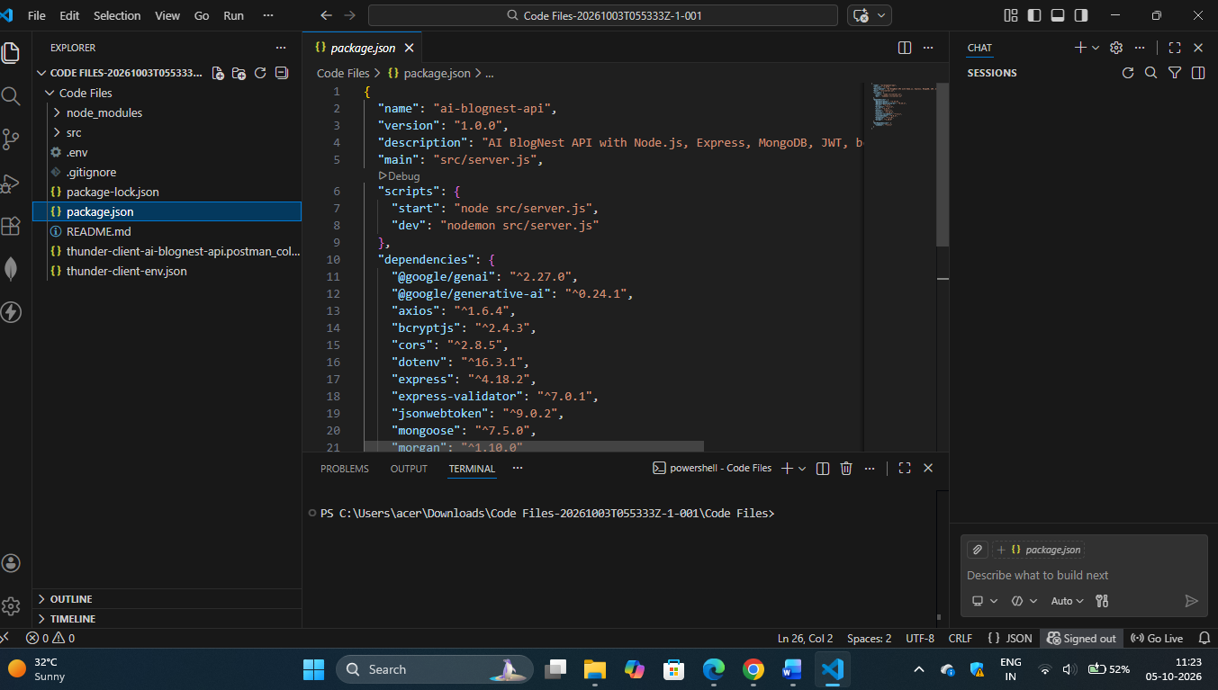

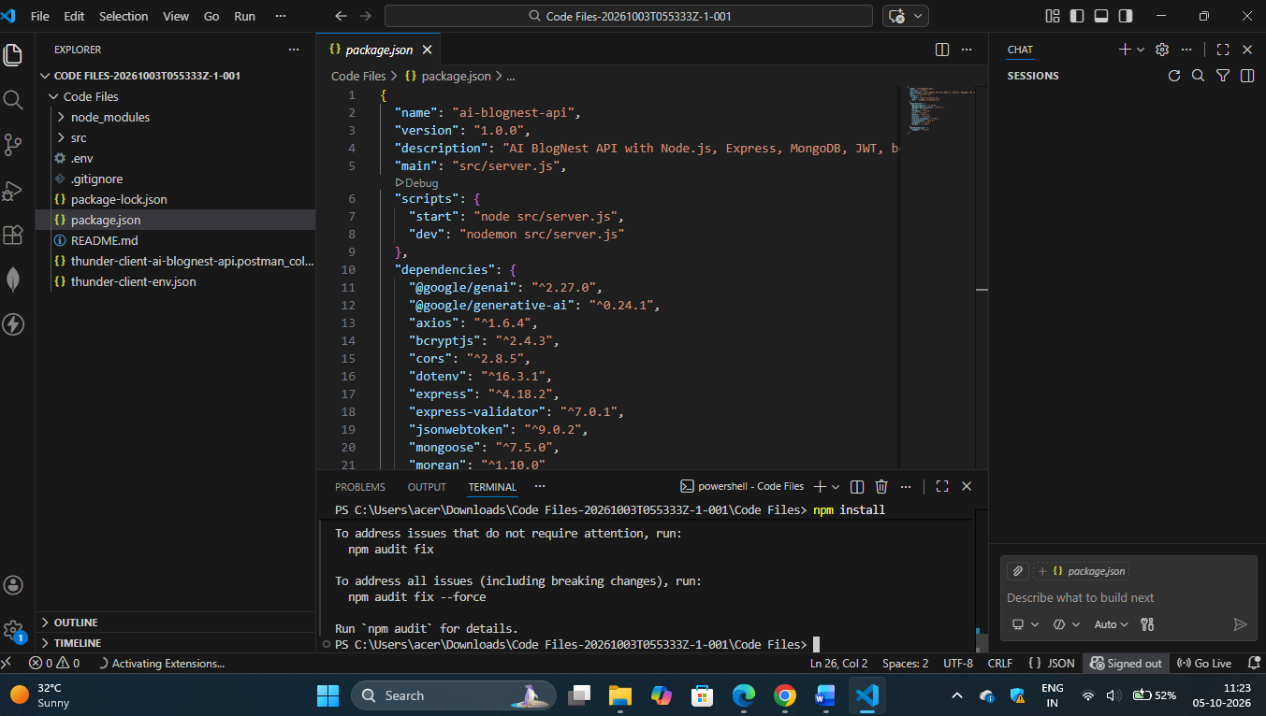

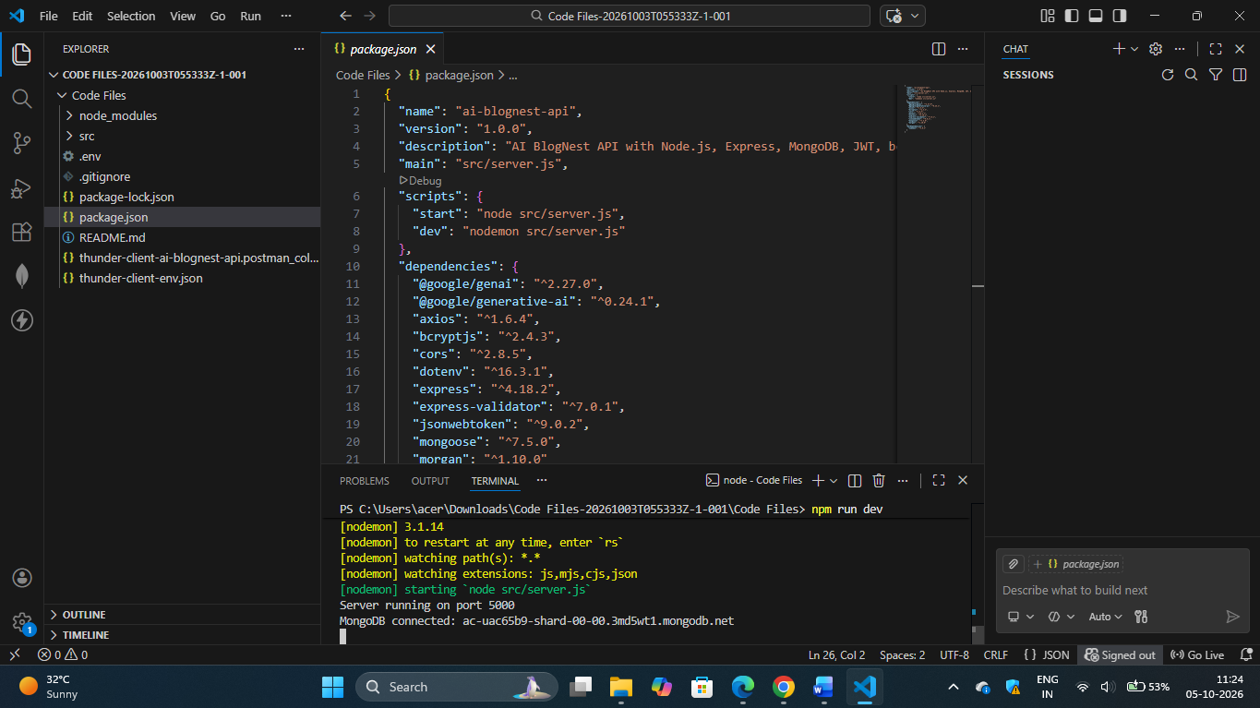

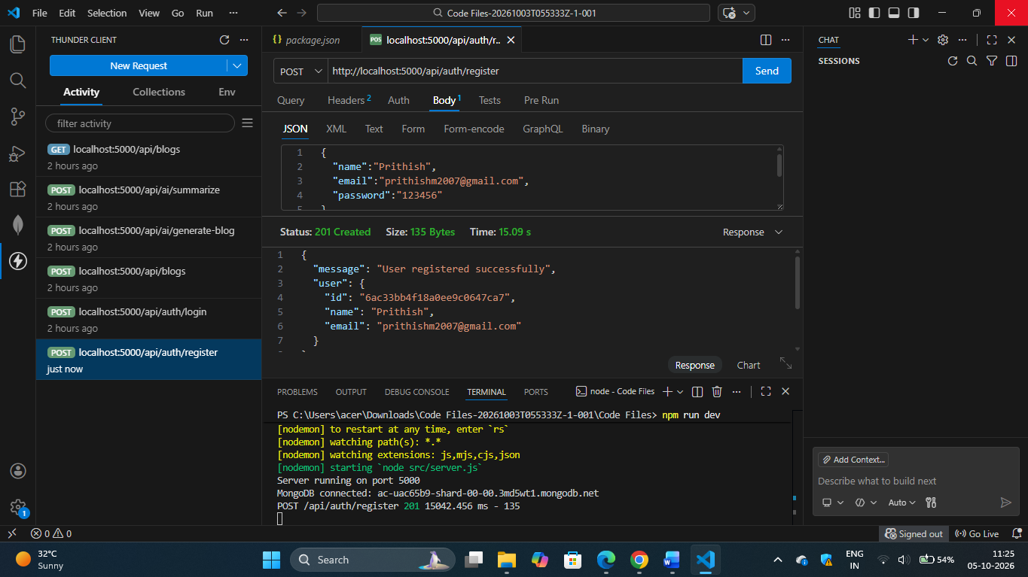

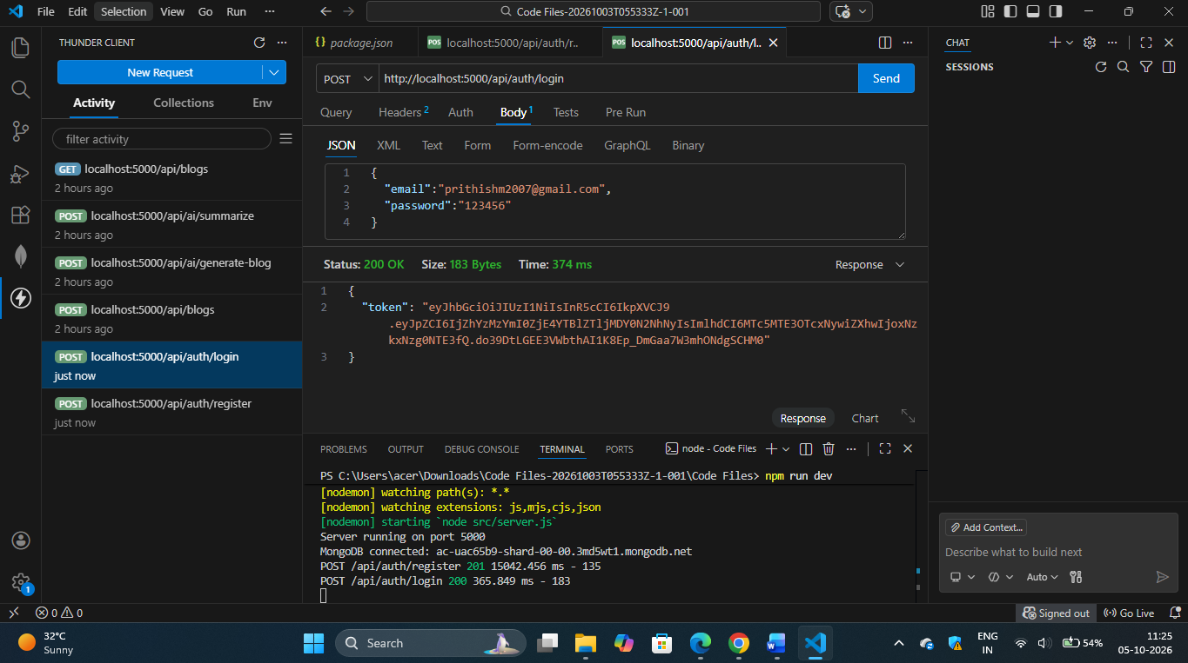

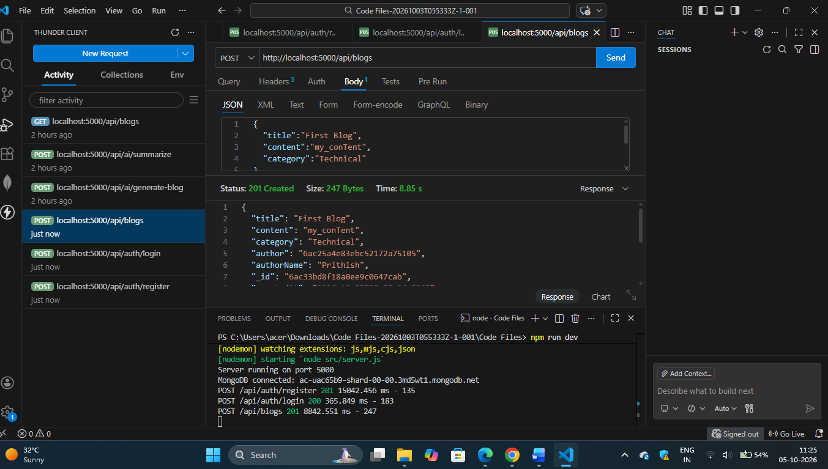

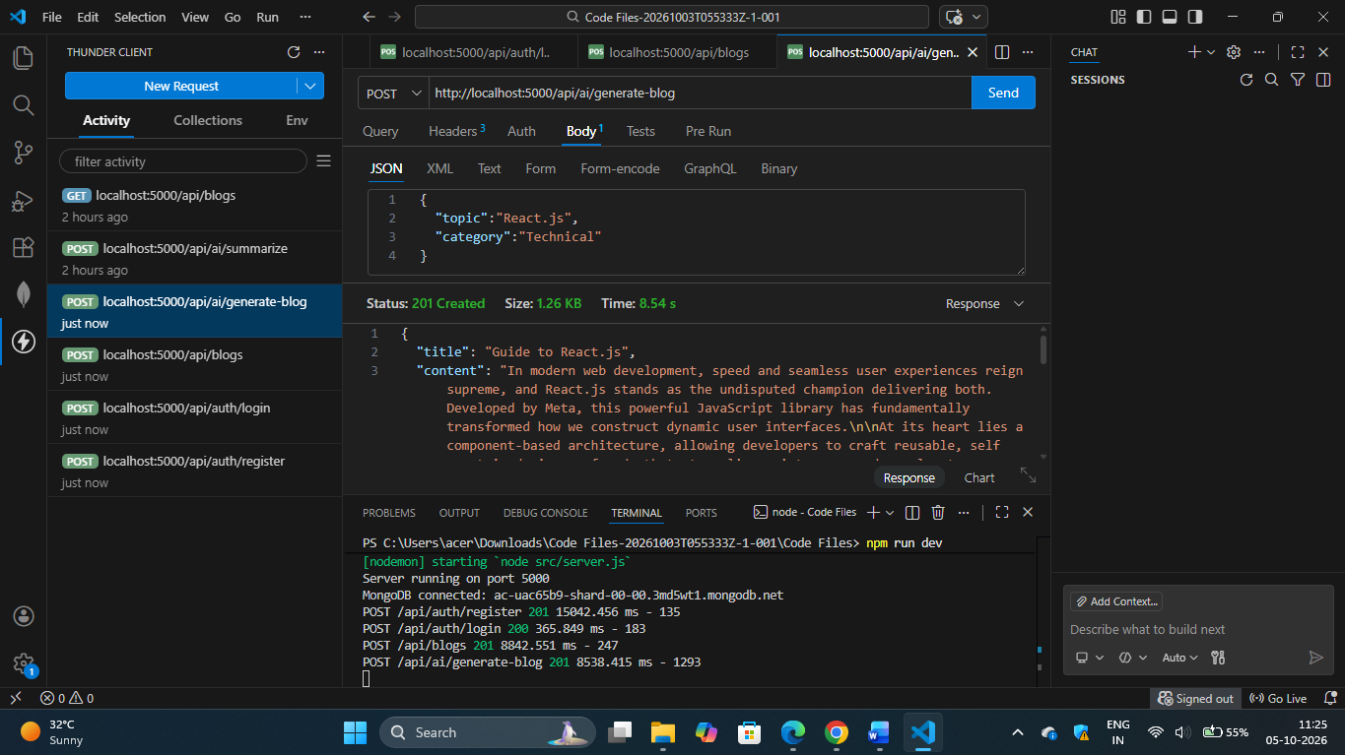

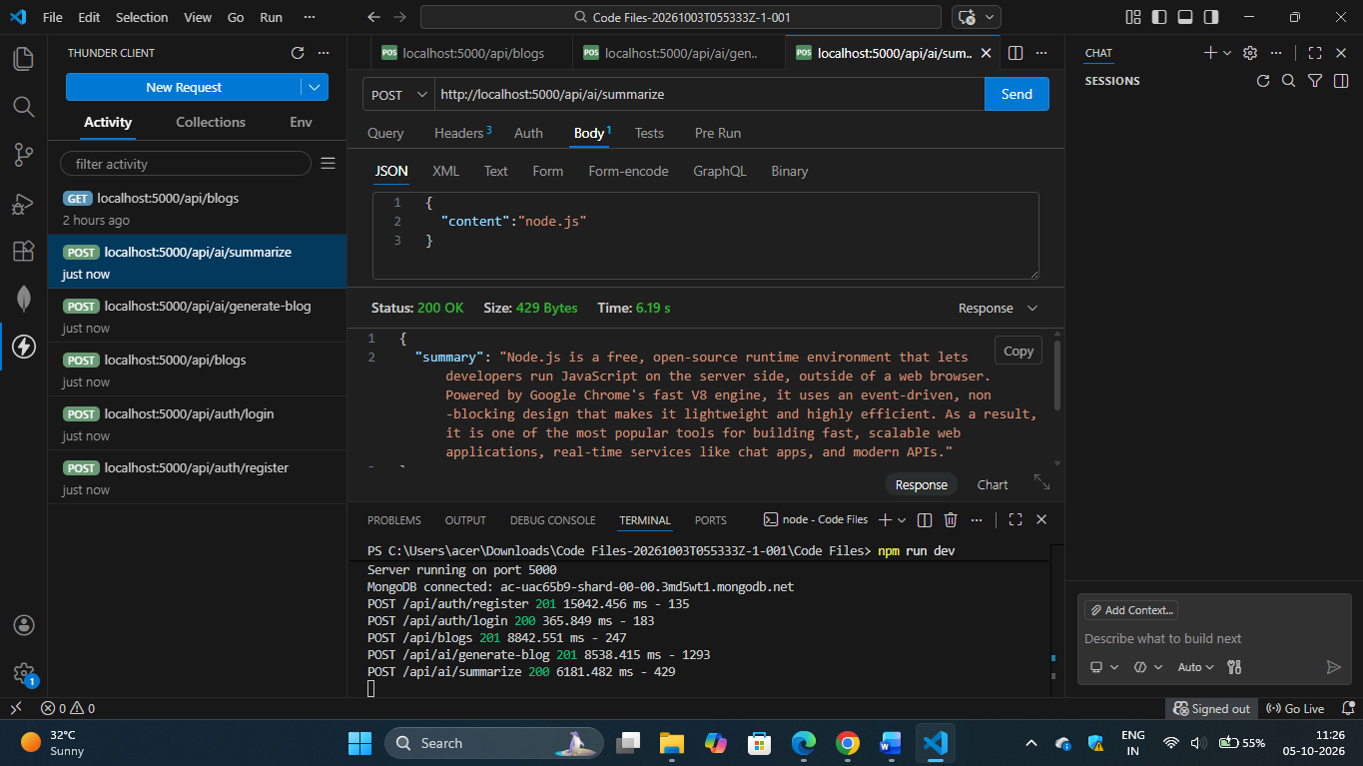

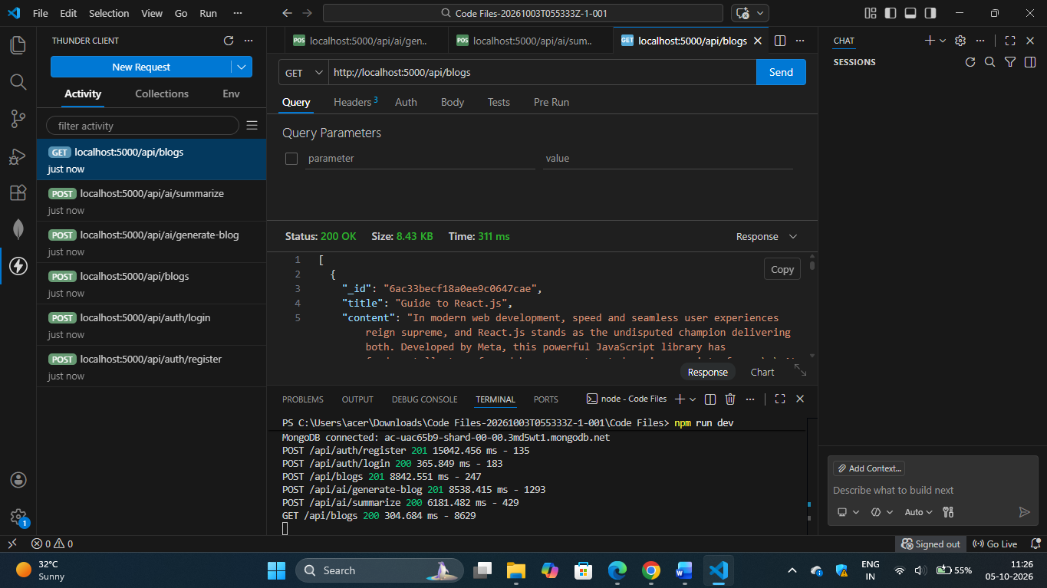

12.Known Issues:-

AI BlogNest API may experience issues when the MongoDB connection is unavailable, environment variables are missing, or the AI service reaches an API limit. Generated content can also vary depending on the prompt and AI response. Network delays may affect AI generation time. These issues can be reduced through proper validation, error handling, logging, retries and clear user messages.

13.Future Enhancements:-

- AI-powered title, summary and keyword generation.
- AI-based grammar and readability improvement.
- AI-assisted blog SEO suggestions.
- Image generation or intelligent image recommendations.
- Advanced blog search and category filtering.
- Comment and like systems.
- Bookmarking and reading history.
- Role-based admin and moderation features.
- Analytics dashboard for views and engagement.
- Rate limiting, caching and improved API security.
- Cloud deployment and automated CI/CD.
- Swagger/OpenAPI documentation and automated API testing.

14.CONCLUSION:-

In conclusion, AI BlogNest API provides a structured backend solution for modern blogging applications. It combines RESTful API design, user authentication, MongoDB data storage and AI-assisted content generation to simplify the blog creation process. The modular architecture separates routes, controllers, services and data models, making the application easier to maintain and extend. The project can be further improved with advanced AI features, stronger security, analytics, moderation and cloud deployment. Overall, AI BlogNest API demonstrates how conventional blog management can be enhanced with artificial intelligence while maintaining a scalable and organized backend architecture.

